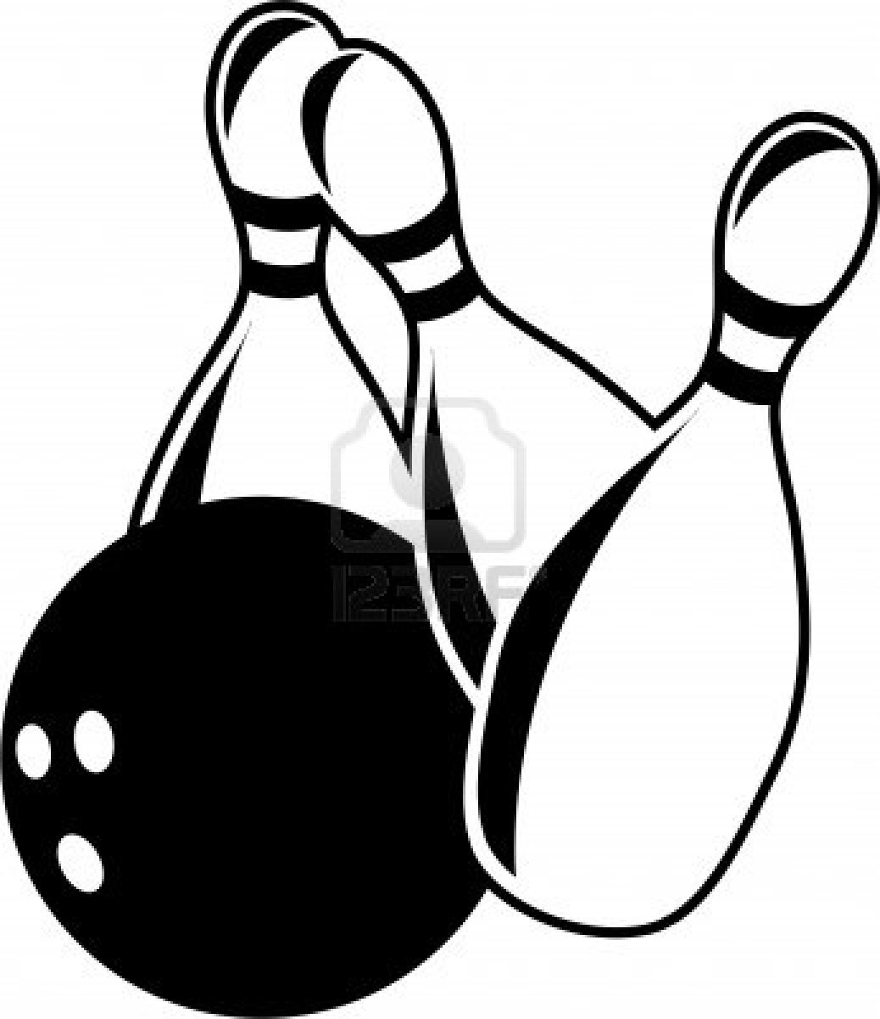
Group name attending

________________
BOWLING EVENT
Details of cubs and meals:
Choose: nuggets / burger / cheese burger / fish fingers / veggie fingers

Cubs names | Meal choice (see above) | Lane number | Score (after first game)

Please hand the form to the reception desk on arrival to make sure cubs are booked in, lanes allocated and meals ordered.
Please check the lane number is correct and add score after first game and then hand form to Carl (1st Swindon Cubs) as soon as possible.
There are trophies for highest average score and highest individual score so make sure sheets are completed and handed in quickly.

