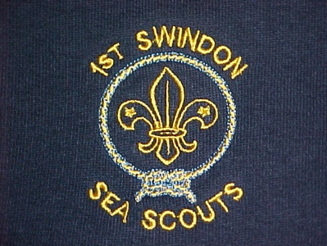

NOTICE
Annual General Meeting (AGM)

1st Swindon Sea Scouts Group Council
To be held at Bowmoor Sailing Club
Friday 20th June 2014 at 18.30

Dear Friends of 1st Swindon Sea Scouts

In order to ensure the continued good governance of the 1st Swindon Sea Scouts and to comply with Charity Commission Law and the requirements of the Scout Association, the Executive committee is serving notice of this year’s Annual General Meeting.

We are inviting all those involved and supporting 1st Swindon to attend and hope that you will be able to support the event. We expect the formal business to last no more than three quarters of an hour.

Whilst the Chairman’s post is an appointment nominated by the Group Scout Leader (GSL), we are inviting nominations for the positions of Group Treasurer, Secretary and Grants/fundraising Officer.
Nomination forms are available from the GSL or Section Leader.

Following the formal business it is intended to hold a BBQ along with activities for all to get involved in, including archery.

We look forward to seeing you there.

Best wishes
Simon Dabbs Bryan McGaw
Chairman, Executive Committee Group Scout Leader

