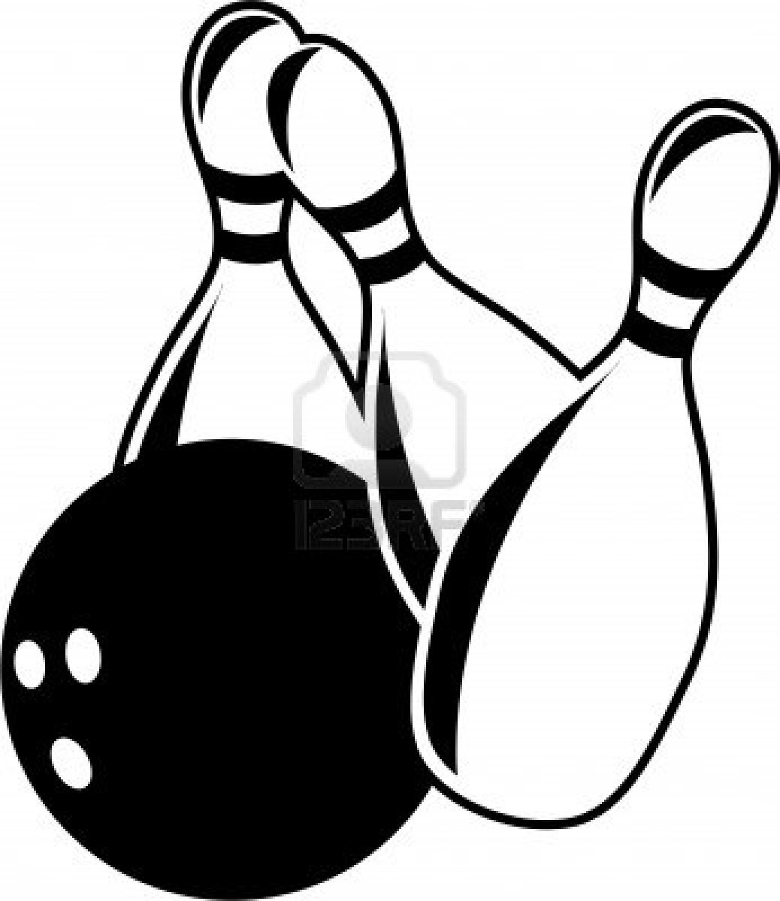
BOWLING EVENT 2018

Name of Group __________________
Details of cubs and meals:
Choose: burger / cheese burger / veggie fingers = £9.99
or fish fingers / chicken nuggets = £10.49
chips and unlimited squash is included in both deals.

Cubs names | Meal choice (see above) | Lane number | Score (after first game)

Please e mail Carl the completed form ahead of the evening.

If there are any amends please confirm these to the reception desk on arrival to make sure cubs are correctly booked in, lanes allocated and meals ordered.

Please check the lane number is correct and add score after first game and then hand form to Carl (1st Swindon Cubs Drake Pack) as soon as possible.
There are trophies for the top 3 highest average scores and top 3 highest individual scores so make sure sheets are completed and handed in quickly.

